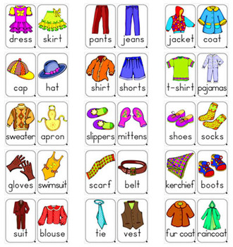

**CLOTHES PICTIONARY**