1. **Read and answer the questions. Write short answers or write the whole sentence:**

**NAME:**

**DATE:**

*Yes, she does/No, she doesn't*

*Yes, she is / No, she isn't*

*Yes, she can / No, she can't*

*She has lunch at two o'clock*

*etc.*

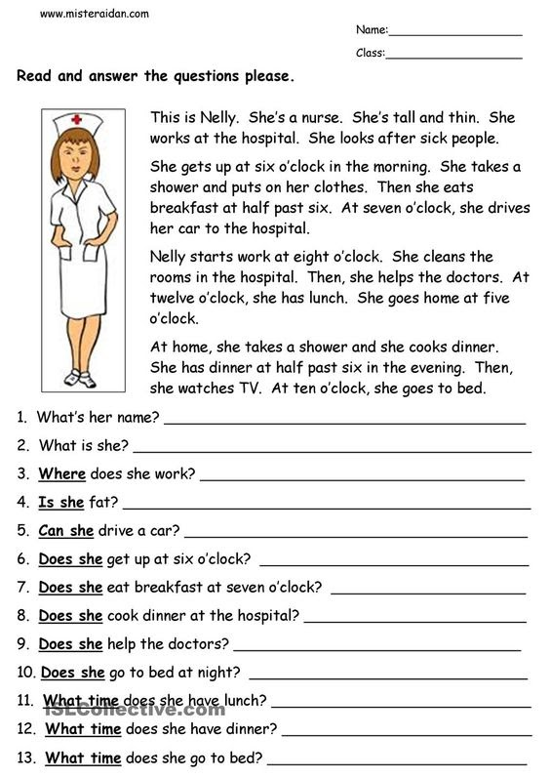

1. What’s her name?
2. What is she?
3. Where does she work?
4. Is she fat?
5. Can she drive a car?
6. Does she get up at seven o’clock?
7. Does she help the doctors?
8. What time does she have lunch?
9. What time does she have dinner?
10. What time does she go to bed?

**2. Complete these gaps with these Possessive Adjectives**

**my - your - his - her - its - our - their**



1. The boy likes ________ school.
2. Lisa visits __________ grandma every day.
3. The cat eats ________ food quickly.
4. I often forget ________ keys.
5. You write in _______ book.
6. Sarah teaches _______ class in the morning.
7. Martin sometimes wears _______ green T-shirt.
8. 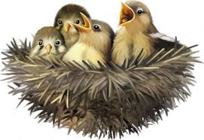The birds always sleep in _______ nest.
9. We do ______ homework at the weekend.
10. They always listen to _______ teachers.
11. **Look at the picture, read the examples and answer.**

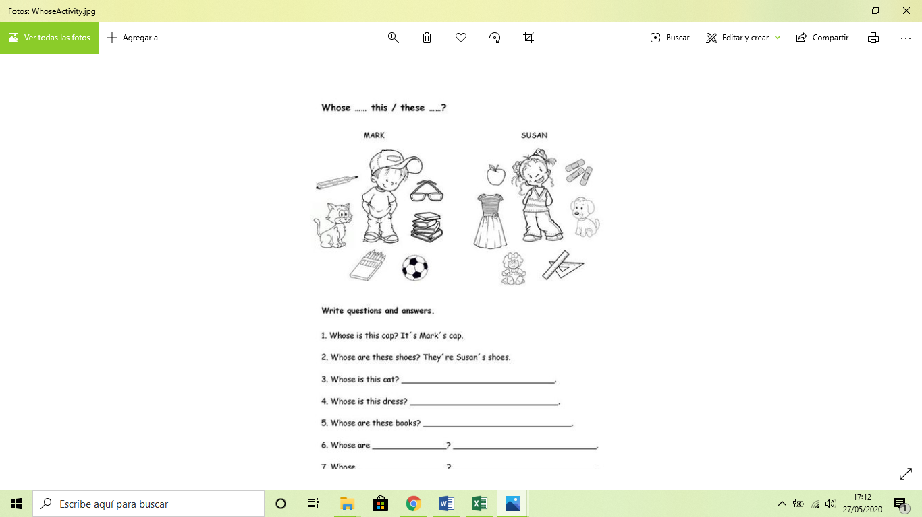

Ex: *Whose is this cap? It’s Mark’s cap.*

*Whose are these shoes? They’re Susan’s shoes.*

* Whose is this dress?
* Whose is this cat?
* Whose is this dog?
* Whose are these books?
* Whose is this apple?

**4. Choose ONE (Elige UNO) of these kids and describe his/her clothes.  Write 5 sentences with *s/he is wearing…***



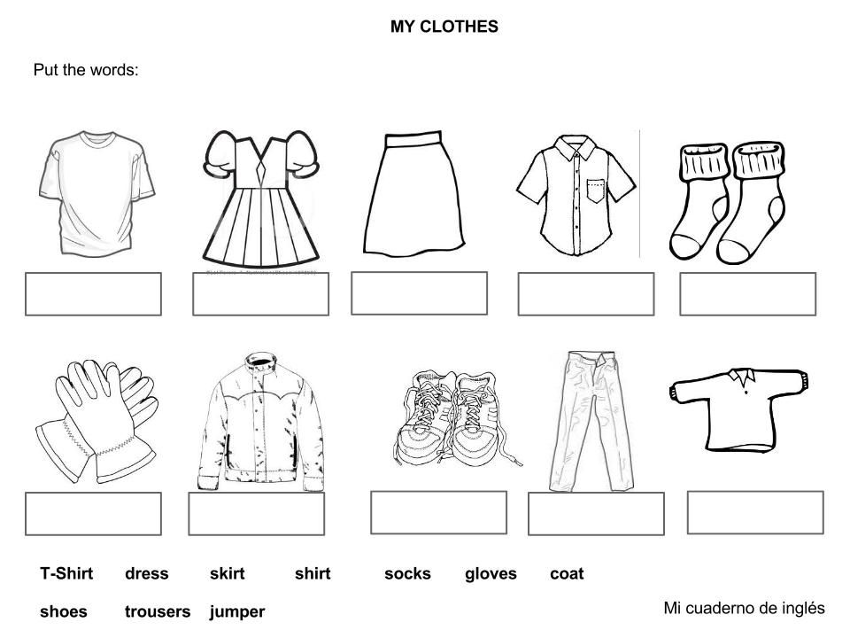**5. Write the words in English**.

         1.   2. 3.   4.     5.

***Write your answers here:***

1:

2:

3:

4:

5: